Part 1: Result of Documentation Coaching
Process Owner / Department / Section | Procedure / Manual / Work Instruction | Comments / Proposed Changes | Remarks / Status
Admin, Accreditation and Faculty Evaluation (Dr. Marife Garcia) | Admission & Registration Procedure | Procedure (college):  - Information campaign  - Application  - CAT  - Evaluation  - Pre-Reg. (exam results, endorsement )  - Requirements  - Documents  - Medical & Dental  - Guidance  - Enrollment (college)  - Registration (college org., the harrow, SSC and NSTP for clustering/reservation)  - Approval and Validation (registrars office) | Already included in the procedure
 |  | Procedure (High School):  - Application & Submission of Requirements  - Documents  - Medical & Dental  - Guidance Clearance  - HSAT  - Evaluation  - HS Enrollment  - Payment (org. fee, developmental & miscellaneous fees) | Already included in the procedure
 | University Accreditation Procedure | Consider to insert process of compliance after each survey visit of accreditation to comply to audit findings and recommendations of the accreditation body. | Already included in the procedure
 |  | Define process for sustaining the accreditation and process for monitoring and evaluation.
 | Faculty Evaluation Procedure | For CCE - Need to define procedure based on the following process steps:  - Notice for Evaluation - Prepare documents (NBC Zonal Center)  - Committee creation  - Evaluation  - Committee  - Director  - Submission of Results (Zonal Center)
For QCE - Need to define procedure based on the following process steps:
- Distribution of Evaluation Tool
- Evaluation (Self, Students, Peer and Supervisor)
- Analysis of Evaluation Results
- Communicate Results
- Submission
Note: Check the need to provide intervention for faculty performance enhancement
Academic Affairs (Dr. Emelyn Villanueva & Team) | Determining the Need to Offer New Program/s | Change company name – Macro Vision Consultancy to Romblon State University
 |  | Forms must be part of Attachments (8.0) and not on the Reference Documents (4.0)
 | Development of New Programs | Include Determining the Need to Office New Programs Procedure
 |  | Consider to consolidate the processes of Determining the Need to Offer New Program/s and process of Development of New Programs into one procedure.  6.1 Determining the Need to Offer New Program/s  6.2 Development of New & Existing Programs (last step is to seek RQAT (new) & accreditation (existing programs) | Already included
 | Promotion of Programs | Procedure already drafted. | Done
 | Design and Development of Curriculum and Syllabus | The drafted procedure was already drafted. Need to include process of developing syllabus. | Already included in the procedure
 | Retention of Students | Determine reference documents.  Need to enhance Performance Indicators. (Percentage of transferred students from one program to another due to failure to satisfy Retention Policy)
 | Classroom Management | Need to use standard template of procedure. Identify the following:  - 1.0 Objective  - 2.0 Scope  - 3.0 Definition of Terms  - 4.0 Reference Documents  - 5.0 Responsibility & Authority  - 7.0 Performance Indicators  - 8.0 Attachments | Already drafted using the standard template.
 | Assessment of Students | Need to use standard template of procedure. Identify the following:  - 1.0 Objective  - 2.0 Scope  - 3.0 Definition of Terms  - 4.0 Reference Documents  - 5.0 Responsibility & Authority  - 7.0 Performance Indicators  - 8.0 Attachments | Already drafted using the standard template.
 |  | Consider to include process for grade computation
 | Student Evaluation for Graduation | Procedure already drafted. Need to correct the use of page connector
 | Graduation of Students and Conferment of Degrees | Procedure already drafted. Need to correct the use of page connector
Auxiliary, Plant Services and Pollution Control Office (APSPCO) | Project Management and Implementation | Need to define procedure based on the following processes steps:  - Kick-off Meeting (with contractor)  - Project Implementation  - Project Inspection  - Concrete Pouring Request  - Rebar Install  - Finishing  - Project Monitoring  - S-Curve  - Updating of Construction Schedule  - Final Inspection (Punchlisting & submission of As Built Plan)  - Project Turn-Over  - COC  - COA
 | General Services Procedure | Need to define procedure based on the following processes steps:  - Houskeeping  - Scheduling  - Implementing Housekeeping Program  - Reporting  - Waste Management  - Segregation  - Collection  - Recovery (MRF)  - Disposal
 | Maintenance | Covers  - Preventive Maintenance  - Corrective Maintenance (Repair)
Supply | Calibration | Need to define process
HR | Competence, Training & Awareness Procedure | Need to cover the following processes:  - Determining HR Training & Scholarship Needs  - Implementation of HR Development Through Training - (Planned and As per Request)  - Implementation of HR Development Through Scholarships  - Monitoring and Evaluation of Training & Scholarship Effectiveness
 | HR Management Procedure | Drafted procedure covers Recruit and Selection only. Need to cover also the following processes:  - On-boarding Orientation  - Performance Evaluation  - Promotion  - Transfer  - Resignation/Retirement  - Termination  - Leave Application  - Payroll Processing (including timekeeping)  - Disciplinary Action
 |  | Need to identify Performance Indicator/s and Attachments (forms) necessary for the execution of the procedure.
 | PRAISE (Program on Awards and Incentives for Service Excellence) | Presented the guideline of RSU for the suggestion and incentive awards system of the university.
Need to define the procedure covering the following process steps:
- Notification
- Nomination/Application
- Initial Evaluation (PRAISE Committee – Shortlisting of candidates)
- Final Evaluation
- Awarding
 | Control of Position Description and Table of Organization Procedure | Creation and communicating Position Descriptions  Revision and communicating the Table of Organization
IGS | Proposal Defense | Consider to consolidate the following processes into one procedure:  - Title Defense  - Proposal Defense  - Final Defense  Suggested Title: Guideline and Standard for Master’s Thesis and Dissertation
Research, Extension & Training Office ( Juniel G. Lucidos) | RSU Extension Control Procedure | Coached with the preparation of the procedure including the required performance indicator
 | RSU Research Control Procedure | Coached with the preparation of the procedure including the required performance indicator
 | RSU Training Control Procedure | Coached with the preparation of the procedure including the required performance indicator
 | SWOT Analysis | Presented SWOT Analysis shall be transferred to the prescribed template and provide business driver (people, technology, performance, compliance obligation)
 | Risk Assessment | Shall finalize the Risk Assessment based on finalized SWOT Analysis
Accounting ( Ms. Cynthia R. Laynesa) | Accounting Control Procedure | Checked the presented procedure and shall transferred to the prescribed template and provide performance indicator | For Registration
 | Bank Reconciliation Control Procedure | Checked the presented procedure and shall transferred to the prescribed template and provide performance indicator | For Registration
 | Preparation of Financial Statement Control Procedure | Checked the presented procedure and shall transferred to the prescribed template and provide performance indicator | For Registration
STA FE CAMPUS | SWOT ANALYSIS | Checked the presented SWOT Analysis and include the compliance obligation for securing special permit for mariculture.
 | Risk Assessment | Coached in the preparation of risk assessment as per reference to SWOT Analysis
STUDENT SERVICES | Accreditation of Student Organization Control Procedure | Shall transfer the procedure into the prescribed template.
 | Securing Permit for Student Activities | Shall consolidate the two processes ( in campus and off campus) into one procedure
COLLEGES OF ARTS AND SCIENCES (Reinberg A. Gicole) | SWOT Analysis | Checked the presented SWOT Analysis and finalize as per identified issues
 | RISK Assessment | Shall prepare the Risk Assessment based on the finalized SWOT Analysis
 | Needs and Expectation | Shall finalize the Needs and Expectation with the actual needs and their respective expectations
RSU STA. MARIA ( Danilo M. Miñon | SWOT Analysis | Shall finalize the presented SWOT Analysis
 | Risk Assessment | Shall prepare the Risk Assessment based on the identified issues (weaknesses and threats) including interested party (CHED)
 | Needs and Expectation | Shall finalize the presented Needs and Expectations
Supply OFFICE ( Analyn Pearl N. Lopez, Cheryl Maulion) | Procurement Control Procedure | Checked the presented procedure and transferred to the prescribed template and align the procedure with the actual process | Done
 | Supply Management Control Procedure | Checked the presented procedure and shall include the following process:  - Receiving  - Releasing  - Inventory  - Report of unserviceable property  Report of waste material | Already included the said processes.  Receiving was included in the process of procurement.
 | External Provider Accreditation and Performance Evaluation Procedure | Shall prepare the procedure for the evaluation of performance of external provider | Done
 | SWOT Analysis | Checked the presented SWOT Analysis | Done
 | Risk Assessment | Shall prepare the risk assessment based on the finalized SWOT Analysis (WEAKNESSES AND THREATS) | Done
 | Needs and Expectations | Checked the presented Needs and Expectations | Done
CASHIER ( Joan Kristine F. De Castro, Alma G.Montojo) | Cashiering Control Procedure | Checked the presented procedure and shall include the following process:  - Disbursement of Salaries and Wages  - Checks/ Cash Payment to various accounts | Already included in the procedure
 | SWOT Analysis | Shall finalize the presented SWOT Analysis to provide the business driver (focus area) | Used PEOPLE, PERFORMANCE & TECHNOLOGY/ EQUIPMENT.
REGISTRAR | Handling of Student Record | Checked the presented procedure and shall complete the process
STUDENT SERVICES (ICJE) | Development of Instruction (Implementation of OJT/ Internship) Control procedure | Checked the presented and shall finalize as per actual process implemented
 | SWOT Analysis | Checked the presented SWOT Analysis and shall transfer to the prescribed template
 | Risk Assessment | Coached in the preparation of Risk Assessment based on the issues identified in SWOT Analysis
LIBRARY ( Nadie Fabila) | Library Control Procedure | Checked the presented procedure and shall include the following process:  1. Issuance of library cards  2. Requesting of Books  3. Organization of Materials  4.Inventory of library materials | Done. Already included in the procedure
 | SWOT Analysis | Checked the presented SWOT Analysis and finalized the identified weaknesses | Already available.
 | Risk Assessment | Shall address the identified weaknesses and threats separately | Already identified risks relevant to the identified issues (weaknesses and threats), however, risks relevant to the requirements of interested parties were not yet included.
 | Needs and Expectations | Needs and Expectation already available | Consider to include Outside Clients (Researchers)
PRODUCTION ( Jeniel A. Santos) | RSU Income Generating Project Implementation Procedure | Checked the presented procedure ready for finalization and attachments of specified forms
MEDICAL ( Abegail Madali) | Medical Control Procedure | Check the presented procedure and shall include the process for issuance of medical certificate, referral process. Shall prepare Work Instruction for triaging.
 | Dental Control Procedure | Shall prepare the procedure for dental process. Shall prepare also Work Instruction for dental tooth extraction, permanent filling, phrophylaxis
BAC | BAC Control Procedure | Checked the presented procedure and shall finalize the procedure
 |  | March 28, 2019
All Department | Implementation Date | The following dates should be followed for the implementation of Quality Management System:  PLAN A PLAN B  Date of Submission of all requirements (1 month before implementation): April 29, 2019 Date of Submission of all requirements (1 month before implementation): May 27, 2019  Implementation Date: June 3, 2019 Implementation Date: June 24, 2019  Internal Audit (1 month after implementation): July 8-10, 2019 Internal Audit (1 month after implementation): July 29-31, 2019  Management review: July 15, 2019 Management review: August 5, 2019  Special Internal audit: July 19, 2019 Special Internal audit: August 9, 2019  MVC Audit: 4th week of July 2019 MVC Audit: 4th week of August 2019  Certification Date Stage 1 audit: 1st week of August 2019 Certification Date Stage 1 audit: 1st week of September 2019  Certification Date Stage 2 audit: 2nd week of August 2019 Certification Date Stage 2 audit: 2nd week of September 2019
The following instruction has been advised to be following for the accomplishment of procedure:
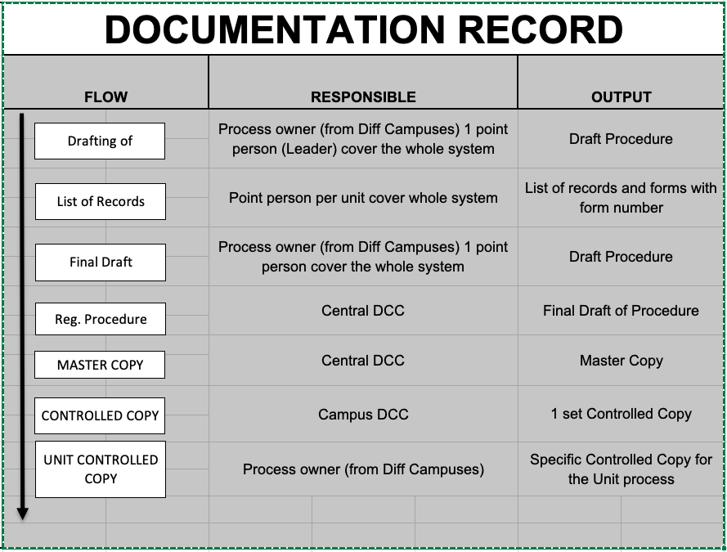
 | Context of the Organization | Coaching/review of the following records for the identification of context of the organization:  - SWOT Analysis Form  - Needs and Expectation of Interested Party  - Risk Assessment Registry  - Opportunities Action Plan
The following flow should be followed in accomplishing the identification of context and risk assessment process:
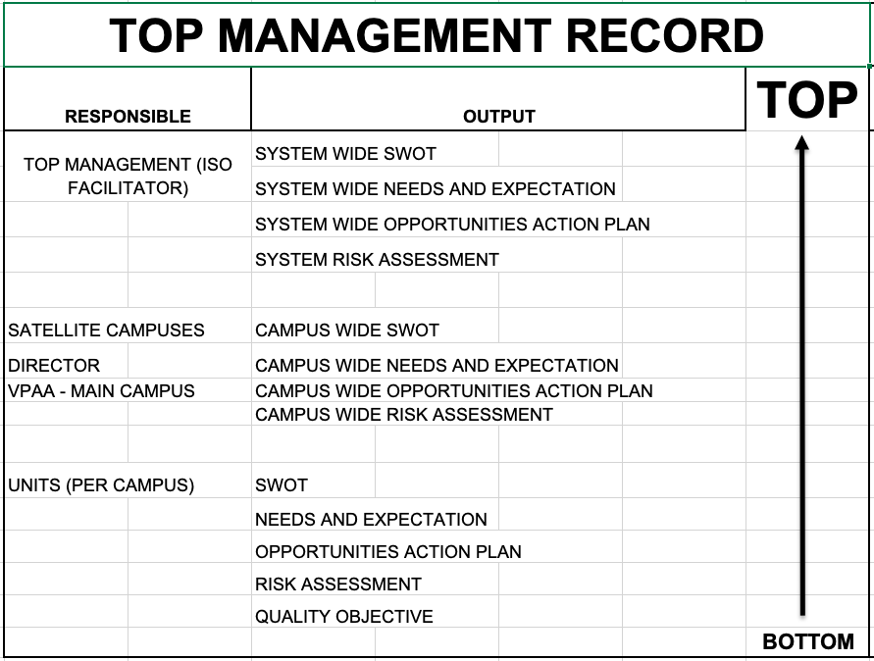
 | Quality Objectives | Coaching of the Quality objectives for each unit per campus.
 | Diagram in Identification of Risk and Opportunities | 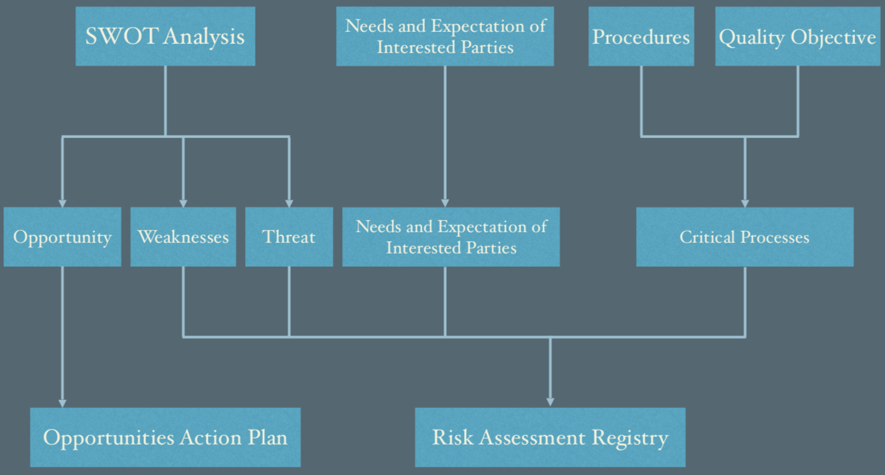  Potential failure to comply with
DCC |  | The following dates should be followed for the registration of procedure (Considering Plan A):  - Date Received (Upper part of DRRRF): April 29, 2019  - Registration Date/Master Copy Stamp Date: June 22, 2019  - Distribution Date/Controlled Copy Stamp Date: June 29, 2019  - Execution date/Implementation Date: June 3, 2019
 | Registration Process | Coaching of the following records for the registration:  - List of Records  - Master Record Control Register  - Document Review Request and Registration Form  - Document distribution retrieval and disposal  - DCC Stamps – required on next visit to procure a stamp
 | Document Distribution, Retrieval and Disposal Form | The following instructions has been advised during the visit:  - The Central DCC shall produce 2 sets of CONTROLLED procedure to be distributed on a campus  - 1 set of procedure – all procedures  - 1 set of procedure – copy of unit available for the campus  - Central DCC shall require the Campus DCC to sign the “Document Distribution, Retrieval and Disposal Form” to reflect received CONTROLLED procedure.  - Campus DCC shall distribute the controlled of the Delivery Unit and require the Delivery Unit to sign the “Document Distribution, Retrieval and Disposal Form”
Budget | Budget Preparation Procedure | The following concerns should be rectified:  - Process for each campus was not yet available during the checking – it is advised that a monitoring sheet should be implemented for each campus for the monitoring of transport of reports from satellite campus to main campus.  - Flow Charting was not yet organized during the checking
 | Budget Execution Procedure | The following concerns should be rectified:  - Process for each campus was not yet available during the checking – it is advised that a monitoring sheet should be implemented for each campus for the monitoring of transport of reports from satellite campus to main campus.  - Flow Charting was not yet organized during the checking
 | Financial Accountability Procedure | The following concerns should be rectified:  - Process for each campus was not yet available during the checking – it is advised that a monitoring sheet should be implemented for each campus for the monitoring of transport of reports from satellite campus to main campus.  - Flow Charting was not yet organized during the checking
 | Quality Objective | Endorsed a Quality Objective:  “To achieve 100% accurate encoding of the proposed budget proposals from the University for the CY 2019”
Academic Affairs (Instruction Delivery) | Procedure | A flowchart has been endorsed during the visit to be use as a guide in drafting the procedure.
 | Assessment of Student Procedure | The following should be rectified:  - The procedure did not describe the accomplishment of item analysis after the assessment process  - The result of item analysis shall be used for the improvement of delivery of lessons for the next sem or during remediation.
 | Retention of Student Control Procedure | The procedure should describe process for the assessment of student who will take the removal exam.
 | Assessment of Student Promotion and Graduation Procedure | The following processes should be rectified:  - The procedure did not include the process of update of “rsuwebsams”  - A process of verification of grades should be done before grades go live online.
Planning | Strategic Planning Process | The following concerns should be rectified:  - No form for the consolidated Strat Plan
 | Monitoring and Evaluation | No drafted procedure during the visit for the monitoring and evaluation
Accounting | Quality Objective | Endorsed the following quality objective:  - “To achieve 100% on-time submission of financial report for CY 2019”  - “To achieve 0 disallowances for the utilization of funds for the CY 2019”
 | Procedure | For finalization of the following procedure:  - Disbursement Control Procedure  - Bank Reconciliation Control Procedure  - Preparation of Financial Statements Control Procedure
STA FE CAMPUS | Needs and Expectations | Already finalized the Needs and Expectation subject for transfer to the registered template
 | SWOT Analysis | Checked the presented SWOT subject for signature
 | Risk Assessment | Checked the presented Risk Assessment ready for signature upon issuance of form number
 | Opportunities Action Plan | Checked the Opportunities Action Plan ready for signature upon issuance of form number
Registrar (Mr. Edwin Karl Fabrequier) | Handling of Students Record | Shall complete the responsibility and authority | Already included in the procedure
 | SWOT Analysis | Shall finalize the SWOT Analysis | Already available
 | Risk Assessment | Shall finalize the risk assessment based on SWOT Analysis and interested party | Already available. Ensure all interested parties were considered.
 | Needs and Expectation | Shall provide the required expectation of identified interested parties | Already available
 | Opportunities Action Plan | Checked the Opportunities Action Plan ready to transfer to registered template and endorsed for signature | Already available
 | List of Records | Shall provide the required form number on the listed forms | Already available
 | Quality Objectives | Proposed quality objective statement:  1. To provide 100% on-time releasing of requested students/alumni records for CY 2019 | Already available
Cashiering | Cashiering Control Procedure | Tagging of students during enrollment, collection of payments, disbursement of salaries/wages and allowances, preparation and issuance of checks, payment of petty cash. Already finalized the procedure | Done
 | SWOT Analysis | Checked the presented SWOT Analysis and shall finalize to the registered template | Done
 | Needs and Expectation | Checked the presented Needs and Expectations ready for transfer to the prescribed template | Done
 | Risk Assessment | Shall finalize the risk assessment based on identified weaknesses and threats in SWOT Analysis and interested party in Needs and Expectations | Already available. Need to ensure all interested parties were considered in determining risks.
 | Opportunities Action Plan | Checked the accomplished Opportunities Action Plan and already based on identified opportunities in SWOT Analysis | Already available
 | Quality Objectives | Proposed quality objective statement:  1. To achieve 100% accurate daily collections and deposits transaction for CY 2019
Library | Library Control Procedure | Shall include the references used in the procedure | Already updated the list of reference documents.
CAJIDIOCAN CAMPUS | Needs and Expectations | Shall finalize the Needs and Expectation based on identified interested parties
 | SWOT Analysis | Shall finalize the SWOT Analysis based on KRA
 | Risk Assessment | Shall prepare the risk assessment based on identified weaknesses and threats in SWOT Analysis and interested party
 | Opportunities Action Plan | Shall prepare Opportunities Action Plan based on identified opportunities in SWOT Analysis
 | Medical Control Procedure | Checked the presented procedure and shall finalize as per discussion on the listed process
 | Dental control Procedure | Checked the presented procedure and shall finalize as per discussion on the listed process
SAN ANDRES CAMPUS | SWOT Analysis | Checked the presented SWOT Analysis and shall transfer to the prescribed business driver | Done
 | Risk Assessment | Shall finalize the risk assessment based on identified issues in SWOT Analysis and interested parties | Done, however, no risk treatment for some risks.
 | Needs and Expectation | Checked the presented Needs and Expectation and shall consolidate for the campus | Done
Institute of Criminal, Justice Education | SWOT ANALYSIS | Checked the presented SWOT Analysis and already aligned with the prescribed business driver
 | Risk Assessment | Shall include the interested parties in addressing its risk
 | Quality Objectives | Proposed quality objective statement:  1. To achieve the passing rate of 65% for licensure examination for school year 2019-2020.
Extension | SWOT Analysis | Checked the presented SWOT Analysis and aligned with the prescribed business driver
 | Risk Assessment | Shall finalize Risk Assessment based on identified weaknesses and threats and interested party
 | Needs and Expectations | Shall finalize the needs and expectation based on identified interested party
 | Opportunities Action Plan | Coached the preparation of Opportunities Action Plan
 | Extension Management Control Procedure | Checked the presented procedure subject for finalization and start with the word “shall” in the description of the procedure
 | Quality Objectives | Proposed quality objective statement:  1. To achieve the required 3,700 persons trained weighted by the length of training for CY 2019
IGS | Master’s Thesis and Dissertation Control Procedure | Checked the presented procedure ready for finalization and document review
 | Quality Objectives | Proposed quality objective statement:  1. To increase by 5% the number of enrollees for School Year 2019-2020
SUPPLY OFFICE | Supply Management Control Procedure | Checked the presented procedure ready for document review
 | Procurement Control Procedure | Checked the presented procedure subject for finalization
 | Evaluation of External Provider Procedure | Checked the presented procedure subject for finalization
 | Calibration Control procedure | Not yet finalized
 | SWOT Analysis | Shall specify the process being addressed with regards to internal and external issues
 | Needs and Expectations | Shall include the COA in the list
 | Risk Assessment | Shall finalized the risk assessment
 | Opportunities Action Plan | Shall prepare the Opportunities Action Plan based on SWOT Analysis
 | Quality Objectives | Proposed quality objective statement:  1. To serve at least 90% of received Purchase Request from the end user for CY 2019
HR | Human Resources Management Procedure | Checked the presented procedure:  Shall provide the reference documents used in the preparation of the procedure
 | Handling of Grievance Procedure | Checked the presented procedure
 | Strategic Performance Management Procedure | Shall provide the responsibility and authority
 | Rewards and Recognition Procedure | Checked the presented procedure
 | Payroll and Remittance Control Procedure | Checked the presented procedure and shall complete the details of the procedure as per clauses.
 | SWOT Analysis | Not yet finalized
 | Quality Objectives | Proposed quality objective statement:  1. To achieve 100% delivery of syllabi per semester for school year 2019-2020.  2. To provide all employees with at least one (1) training for CY 2019.
BAC | BAC Control Procedure | Checked the presented procedure subject for finalization
 | SWOT Analysis | SWOT Analysis not yet finalized
ROMBLON CAMPUS | SWOT Analysis | Checked the presented SWOT Analysis subject for finalization
 | Needs and Expectation | Shall finalize the needs and expectation of interested parties
 | Risk Assessment | Shall finalize the identified weaknesses and threats and needs and expectation
COLLEGE OF ARTS AND SCIENCES | Opportunities Action Plan | Shall provide specific action plan meet the opportunities
CALATRAVA CAMPUS | SWOT Analysis | Shall finalize the SWOT Analysis
Academic  Affairs | Quality Objectives | Proposed quality objective statement:  1. To achieve 100% delivery of syllabi per semester for school year 2019-2020.
Institute of Information Technology | SWOT Analysis | Shall finalize the presented SWOT Analysis based on identified business driver
 | Risk Assessment | Shall prepare the risk assessment of identified weaknesses and threats in SWOT Analysis and identified interested party
 | Needs and Expectation | Shall prepare the needs and expectations of identified interested parties
 | Opportunities Action Plan | Shall prepare the Opportunities Action Plan based on identified opportunities in SWOT Analysis
 | Quality Objectives | Proposed quality objective statement:  1. To achieve 100% delivery of syllabi per semester for school year 2019-2020.
 |  | May 23~24, 2019
Accounting ( Ms. Cynthia R. Laynesa) | Risk Registry | Already identified risks. Need to determine and finalize Risk Treatment.
 | Quality Objective | Objective to achieve 100% on-time submission of Financial Reports for 2019 - need to check first 2018 performance before setting its 2019 objective.
 |  | Need to determine action plans to achieve objectives.
LIBRARY ( Nadie Fabila) | Risk Registry | Need to determine risks relevant to the requirements of the identified interested parties.
 |  | Consider to include the risk that a book/material is misplaced resulting to difficulty in its retrieval.
Admin, Accreditation and Faculty Evaluation (Ms. Desiree) | Risk Registry | Need to ensure all issues (weaknesses and threats) and requirements of interested parties were considered when determining risks.
Academic Affairs (CBA) | SWOT Analysis | Presented SWOT for CBA only. No consolidated SWOT yet for all colleges.
 | Risk Assessment | Presented the Risk Registry for CBA only. No consolidated Risk Registry yet for all colleges.
 | Needs and Expectation | Presented the N&E of Interested Parties for CBA only. No consolidated list of interested parties yet for all colleges.
 | Opportunities Action Plan | Presented the Opportunities Action Plan for CBA only. No consolidated Opportunities Action Plan yet for all colleges.
 | List of Records | Need to consolidate all forms used by Academic Affairs (all colleges) and start assigning form numbers to avoid duplication of codes.
Academic Affairs (IT) | SWOT | Presented SWOT for IT only. No consolidated SWOT yet for all colleges.
 | Needs and Expectation | Presented the N&E of Interested Parties for IT only. No consolidated list of interested parties yet for all colleges.
 | Risk Registry | Did not include the risks relevant to the requirements of interested parties.
Supply | Calibration Procedure | No procedure yet for calibration. Need to describe processes for:  - Generating Masterlist of Equipment for Calibration  - Monitoring of Calibration Due Dates  - Requesting calibration of equipment.  - Updating of Calibration Status of Equipment
HR | Risk Registry | Risks not identified.
 |  | Interested parties were not considered in determining risks.
 | Payroll and Remittance | Need to fix flowchart of procedure.  - No “END” on each process flow  - Some processes has only one step. Consider to breakdown the process steps.
STUDENT AFFAIRS (Guidance and Placement Services) | SWOT Analysis | Presented SWOT for Guidance only.
 | Risk Registry | Need to correct rating of likelihood. Max. rating of likelihood and severity is only 5. Dept. used rating scale of 1~10.
San Fernando Campus | Risk Registry | Some units were not able to consider the requirements of interested parties in determining risks.
SAN ANDRES CAMPUS | Risk Registry | Not all risks have risk treatment.
San Agustin Campus | Risk Registry | Not all weaknesses and threats were considered in determining risks (for research extension)
Academic Affairs | Assessment of Students | Consider to include forms used for computation of grades.
 | Approval Of Off Campus Student Activity Procedure | Need to align format of procedure with the standard elements of RSU procedure:  - 1.0 Objective  - 2.0 Scope  - 3.0 Definition of Terms  - 4.0 Reference Documents  - 5.0 Responsibility & Authority  - 6.0 Procedure  - 7.0 Performance Indicators  - 8.0 Attachments
OSA | Off-Campus Activities Control Procedure | Need to identify reports
Suggested additional performance indicator:
- All off-school activities are supported with terminal reports/accomplishment reports.
 | Risk Registry | Interested parties were not considered in determining risks.
 | Quality Objectives: | Suggested Quality Objective:  - To reduce student related violations from ____ to ____ for the year 2019.
Sta. Fe | Risks Registry | Need to finalize risk registry for the following units:  - Library  - Cashier  Note: Ensure identified issues are aligned to the actual issues of the campus.
Clinic | Medical Procedure | Need to align format of procedure with the standard elements of RSU procedure:  - 1.0 Objective  - 2.0 Scope  - 3.0 Definition of Terms  - 4.0 Reference Documents  - 5.0 Responsibility & Authority  - 6.0 Procedure  - 7.0 Performance Indicators  - 8.0 Attachments
 | Needs and Expectations of Interested Parties | Need to include Clinics and Hospitals (external) as additional interested parties.
Faculty and Staff Development | Competence, Training & Awareness | Need to cover the following processes:  - DETERMINING HR TRAINING & SCHOLARSHIP NEEDS  - IMPLEMENTATION OF HR DEVELOPMENT THROUGH TRAINING  - IMPLEMENTATION OF HR DEVELOPMENT THROUGH SCHOLARSHIPS  - TRAINING EVALUATION
 |  | Drafted procedure covers the implementation of Staff and Faculty Development Through Scholarship.
AUX | Project Management Procedure | Need to identify person responsible for every process step and records needed.
 | Maintenance Procedure | Procedure must contain the following processes:  - Preventive Maintenance  - Scheduling  - PM Inspection  - Reporting  - Corrective Maintenance  - Reporting of Equipment Breakdown  - Evaluation and Assessment  - Repair  - Updating of Record
Sta. Maria | Risk Registry | Interested parties were not considered in determining risks.
Research | Risk Registry | Need to finalize Risk Registry
Calatrava | Risk Registry | Need to finalize per unit and overall risks
All Department | Implementation Date | The following dates should be followed for the implementation of Quality Management System:  PLAN C PLAN D  Date of Submission of all requirements (1 month before implementation):July 22, 2019 Date of Submission of all requirements (1 month before implementation): August 5, 2019  Implementation Date: Aug. 23, 2019 Implementation Date: Sep. 5, 2019  Internal Audit (1 month after implementation): Sep. 23-27, 2019 Internal Audit (1 month after implementation): Oct. 7~11, 2019  Management review: Sep. 30, 2019 Management review: Oct. 14, 2019  Special Internal audit: Oct. 4, 2019 Special Internal audit: Oct. 18, 2019  MVC Audit: 2th week of Oct. 2019 MVC Audit: 4th week of Oct. 2019  Certification Date Stage 1 audit: 3rd week of Oct. 2019 Certification Date Stage 1 audit: 1st week of Nov. 2019  Certification Date Stage 2 audit: 1st week of Nov. 2019 Certification Date Stage 2 audit: 4th week of Nov. 2019
 |  | July 22, 2019
San Andres | SWOT Analysis (Student Affairs) | The existing Quality policy was not in the record.  Opportunities mentioned in the opportunities action plan did not match the opportunities mentioned in the SWOT Analysis
 | Needs and Expectation of Interested party | The record has some needs and expectation statement that has been stated as “…” | Be specific
 | Risk Assessment | Significant risk has no action plan  “Some students will not be able to finish college due to program closure”  No critical process taken from the Quality Procedure.
 | SWOT Student Service | The record has conflicting statement from strength and opportunities
 | Quality Objectives (Student Service) | “To achieve 100% implementation of the approved _______ of the student Service for SY 2019-2020”
 | Needs and Expectation (research Extension) | Include President and main campus
 | Quality Objectives Research extension | Recommended the following quality objectives:  “To achieve the required 1 submitted and presented research for the SY 2019-2020.”  “To achieve the required 1 implemented research for the SY 2019-2020.”
 | Quality Objectives registrar | “To provide 100% on-time releasing of requested student/alumni records based on the Citizens Charter for the SY 2019-2020”
 | Opportunities action plan (Registrar) | Photocopier was mentioned however not mentioned in the SWOT analysis
 | Needs and expectation of interested party (DCC) | No output during the audit.
Santa Fe | Risk Assessment | The record did not include critical process.
 | Quality Objectives (Student Service) | “To achieve 100% implementation of the approved _______ of the student Service for SY 2019-2020
 | Quality Objectives (Production) | To achieve a total of ____ kg of production every harvesting period (every semester) for ____ fish for the year 2019.
 | Risk (research extension) | No record
 | Opportunities action | No record
Cash | Cashiering Control Procedure | A recent expiration of contract with the online service provider has occurred and the procedure ha no manual process for the following:  - Control of Documentary Stamp Collections  - Tagging of Student during enrollment | A recent delevl
 | Context of the organization | The following records are affected due to the recent development of discontinuity of online system service provider:  - SWOT Analysis  - Risk Assessment registry  - Opportunities action plan
Registrar | Handling Student records | The procedure should be revised to reflect manual process of enrollment and “Dropping, Adding and Changing”
 | Context of the organization | The following records are affected due to the recent development of discontinuity of online system service provider:  - SWOT Analysis  - Risk Assessment registry  - Opportunities action plan
San Fernando | Quality Objectives (registrar) | To provide 100% on-time releasing of requested student/alumni records based on the approved Citizens Charter for the SY 2019-2020
 | Quality Objective (Academic Affairs) | The following quality objectives has been recommended:  “To provide Timely delivery of instruction by 100% delivery requirements of the approved syllabus within the SY 2019-2020.  “To achieve ___% passing rate during the LET for SY 2019-2020.”  “To achieve __% students passing rate per subject for all subjects open for the SY 2019-2020.”
 | Quality Objective (IGS) | The achieve _% passing rate for IGS enrolled students for the SY 2019-2020.
 | Quality Objectives (Cash) | To achieve 100% accurate daily recording and reporting of collection and deposit by preventing occurrence of under and over deposit within the AY 2019-2020.
 | Quality Objectives (Production) | To achieve a total of ____ kg of production every harvesting period (every semester) of organic fertilizer for the year 2019.
 | Quality Objective (AUX) | To achieve 100% implementation of the preventive maintenance plan of vehicle and facilities of the Campus for the SY 2019-2020.
 | Quality Objective (BAC) | To achieve 100% evaluation of all accredited external provider within the SY 2019-2020.
AUX | Procedure | The following procedures was not yet available during the visit:  - Maintenance of University Equipment and Property  - General Services Provision Procedure  - Project Management Procedure - no process for by admin | Consultant helped the process owner in drafting the procedure
 | SWOT Analysis | The record was not yet finalized.
 | Needs and Expectation of Interested party | President should be added as one of the interested party
 | Quality Objective | The record was not available during the checking
 | Risk Assessment | The record has no critical processes.
All Department | Quality Objective | The following quality objectives can be considered:  Department Quality Objective  Cash To achieve 100% accurate daily recording and reporting of collection and deposit by preventing occurrence of under and over deposit within the AY 2019-2020.  Production To achieve a total of ____ sacks of production every harvesting period (every semester) of organic fertilizer for the year 2019.  IGS The achieve _% passing rate for IGS enrolled students for the SY 2019-2020.  BAC To achieve 100% evaluation of all accredited external provider within the SY 2019-2020.  Registrar To provide 100% on-time releasing of requested student/alumni records based on the approved Citizens Charter for the SY 2019-2020  Academic Affairs “To provide Timely delivery of instruction by 100% delivery of the required deliverables based on the approved syllabus within the SY 2019-2020.  “To achieve ___% passing rate during the LET for SY 2019-2020.”  “To achieve __% students passing rate per subject for all subjects open for the SY 2019-2020.”  Research To achieve at least one (1) completed research for the SY 2019-2020.  Library To acquire at least an additional __% of books in the library for the year 2019-2020.  Student Service “To achieve 100% implementation of the approved _______ of the student Service for SY 2019-2020  AUX “To achieve 100% Implementation of Preventive Maintenance activities for all equipment and infrastructure of the scholl based on the approved annual preventive maintenance plan.  Supply To ensure 100% calibration of measuring equipment for the SY 2019-2020.  Note: The Quality objectives should be established by each unit/office, the quality objectives mentioned above are just sample quality objectives created during the coaching activity. Offices/unit not mentioned above should establish their own quality objective subject for checking of the consultant during the next visit.  Note: Quality Objectives mentioned above can be adopted by all campuses.  Recommendation: Main campus should establish a quality objectives to adopted by all campuses. Targets and baseline data may differ from campus to campus.
CALATRAVA | Needs and Expectation of Interested party (Registrar) | The following interested party should be included:  - President  - Main Campus
 | Needs and Expectation of Interested party (Registrar) | No expectation for alumni and parents was not indicated
 | Risk Assessment Registry (Registrar) | The following was not addressed in the risk assessment  - Weaknesses and Threats  - Needs and Expectation of interested party  - Critical Processes
 | Needs and Expectation of Interested party (Academic Affairs) | The following interested party should be included:  - President  - Main Campus
 | Risk and Opportunities action plan | No record for the academic affairs for the following:  - Risk Assessment  - Opportunities Action Plan
 | Needs and Expectation of Interested party (Cash) | The following interested party should be included:  - President  - Main Campus
 | Risk Assessment Registry (Cash) | The following was not addressed in the risk assessment  - Weaknesses and Threats  - Needs and Expectation of interested party  - Critical Processes
 | Risk Assessment Registry (Student Services) | The following was not addressed in the risk assessment  - Weaknesses and Threats  - Needs and Expectation of interested party  - Critical Processes
 | Needs and Expectation of Interested party (Student Services) | The following interested party should be included:  - President  Main Campus
 | Opportunities action Plan (Library) | The opportunities action plan did not match the stated opportunities in the SWOT analysis
 | Risk Assessment Registry (Library) | The following was not addressed in the risk assessment  - Weaknesses and Threats  - Needs and Expectation of interested party  - Critical Processes
 | Opportunities (Research) | Opportunities in the records was not traceable in the SWOT analysis
System Break down | Memo | A memo for the occurrence of discontinuity of the Cloud based system should be released to advise everyone to do manual processing of request.
 | Procedure | The following unit/office should revise their procedure due to the effect of system breakdown, the procedure should describe the manual procedure and include a process for shifting from automated to manual process:  - Admission Office  - Academic affairs  - Cashier  - Registrar
Lead Auditor | Memo | A Memo/letter of designation should be released for the appointment of the following:  - Lead Auditor  - Internal auditors
 | Detailed audit Plan | Should be prepared 1 week before the audit  Reserve an auditor designated to audit the Internal audit and Management review
 | Internal audit Activity | The following steps shall be followed in the conduct of Internal audit:  - The Annual Audit Plan should be established by the ISO Facilitator to establish twice a year schedule of Internal Audit Activity  The annual audit plan should be updated by the ISO Facilitator every after the audit to reflect the result of every internal audit activity  - A Internal audit memo shall be created by the Lead Auditor and shall be released 1 week before the internal audit activity with the attachment of the Detailed audit Plan  - The Internal audit memo shall be received by each office/unit by signing the internal audit memo.  - The internal auditors should draft the internal audit checklists based on the procedure assigned for them  - The lead auditor shall conduct an opening meeting and secure a minutes of the meeting and attendance sheet.  - The internal audit report should be updated by the lead auditor summarizing the result of the internal audit activity. The summary should contain the nonconformities, good observations and observations for improvement.  - The lead auditor should conduct a wrap up meeting to discuss all audit findings.  - The lead auditor shall conduct a closing meeting and secure a minutes of the meeting and attendance sheet  - The auditors should discuss their audit findings during the closing meeting an issue corrective action request to all non-conformity.  - The iso facilitator should conduct an evaluation to the internal auditors about their performance during the audit activity.  - The lead auditor should update the list of internal auditor to reflect the status of all auditors.  - The lead auditor should update the record for internal auditors to reflect the procedures audited and the element of the standard that has been covered during the audit activity.  Note: two auditors should be reserved for the conduct of special internal audit which is a separate audit schedule after the management review meeting that will cover the elements of “Internal audit” and “management review”.  Note: the special internal audit should follow the described process above.  Note: the internal audit activity shall not be conducted without 1 month of implementation of the management system.
ISO facilitator | Quality Policy | Romblon State University, a Educational Institution engaged in the provision of college level educational services is committed to provide Quality Services to all learners enrolled within the educational institution.  To achieve this goal RSU commits to:  - Provide relevant services to students and other stakeholders in both the government and private sectors with the highest standard of quality and value within our capabilities and resources according to the needs of the clientele  - Provide services to student compliant with applicable regulatory and statutory requirements  - Ensure people working for and under its control are empowered and competent to handle issues and to further improve its services.  - To continually improve the effectiveness of the QMS at all time for client satisfaction | Subject for review
 | Management Review | The following steps should be followed for the conduct of management review activity:  - A management review memo shall be released nu the ISO Facilitator informing every Office/Unit about the conduct of the management review meeting  - All Offices/Unit shall receive the management review memo by signing the memo.  - The ISO facilitator shall get the attendance of the management review meeting. The following personnel’s are required to attend:  - President  - Vice President  - Office/Unit Heads  - And all reporters  - The management review meeting should be conducted and be recorded by accomplishing a minutes of the meeting.  - The following topic shall be discussed during the management review activity:  - Status of action from previous management review - to be reported by the ISO Facilitator  - Review of the Quality Policy – to be reported by the ISO facilitator  - Changes in the SWOT Analysis – to be reported by all Units/Office  - Changes of Needs and Expectations – to be reported by all Units/Office  - Customer Satisfaction and Feedback from relevant interested party - to be reported by the ISO facilitator  - The extent to which Quality Objectives have been met - to be reported by the ISO facilitator  - Process performance and conformity of products and services –  - Non conformities and corrective actions - to be reported by the ISO facilitator  - Monitoring and Measurement result (budget utilization)– to be reported by Budget office  - Internal audit result – to be reported by the Lead Auditor  - The performance of external provider – to be reported by the Property and Supply Office  - Manpower requirement – to be reported by the Human resource office  - Equipment/Facilities - to be reported by the Property and Supply Office  - Assessment of effectiveness of the action taken to address Significant Risk – to be reported by all Office/Unit  - Status of Opportunities – to be reported by all Office/Unit  - Opportunities for Improvement - to be reported by the ISO facilitator  - All reports pertaining with the management review activity shall be signed and be submitted to the ISO facilitator.
HIGH SCHOOL (MAIN CAMPUS) | Junior High School Admission Procedure | Checked the presented procedure and shall finalize the procedure as per step by step process for admission.
 | Senior High School Admission Procedure | Checked the presented procedure and shall finalize the procedure as per step by step process for admission.
 | SWOT Analysis | Checked the SWOT Analysis and finalize the identified internal and external issues and include the internal processes.
 | Risk Assessment | Checked the presented Risk Assessment and align to SWOT Analysis. Shall include the internal processes such admission and assessment and provide its risks
 | Opportunities Action Plan | Checked the presented Opportunities Action Plan and shall be based on opportunities identified in SWOT Analysis
 | Needs and Expectation of Interested Parties | Checked the presented Needs and Expectations and shall provide the required form number
 | Quality Objective | Checked the presented Quality Objective and shall be measurable objective statement.
Medical and Dental Services | Medical Control Procedure | Checked the presented procedure still for finalization of the template with regards to clause numbering
 | Needs and Expectation | Shall include other interested party such as RHU, LGU, DOH, RPH
LIBRARY (Imelda Bantola) | Risk Registry | Identified interested parties already included in Risk Assessment Registry
 |  | Consider to include the risk that a book/material is misplaced resulting to difficulty in its retrieval. Still not included in the list.
Guidance (Hedy Fontamillas) | SWOT Analysis | Checked the presented SWOT Analysis ready for signature
 | Risk Assessment Registry | Checked the presented Risk Assessment and shall provide the action plan for all identified risks
 | Opportunities Action Plan | Checked the Opportunities Action Plan ready for signature
 | Quality Objective | Shall provide a time-bounded quality objective statement and follow the legend for updating the quality objective.
IIT (Marvin Rick G. Forcado) | SWOT Analysis | Checked the presented SWOT Analysis and shall include the Quality Policy statement
 | Risk Assessment | Checked the presented Risk Assessment and shall include the identified weaknesses and threats in Technology and equipment. Shall also include the identified interested party and check the likelihood and severity used in assessment of risk
 | Opportunities Action Plan | Checked the presented Opportunities Action Plan and shall update the time frame
 | Quality Objectives | Shall update the quality objective and shall provide a time-bounded statement
ICJE | Risk Assessment | Checked the presented Risk Assessment and shall align with the updated SWOT Analysis and include the interested party.
 | Quality Objective | Shall update the Quality Objective
Registrar | Handling of Students Records | Shall update the procedure based on actual process
 | SWOT Analysis | Shall update the SWOT Analysis based on actual process from cloud-based enrollment system to LAN-based enrollment system
 | Risk Assessment | Checked the presented Risk Assessment and aligned with the updated SWOT Analysis
 | Opportunities Action Plan | Shall align the identified opportunities based on SWOT Analysis
 | Quality Objective | Shall update the Quality Objective based on recorded data.
STA MARIA | Extension Management Control Procedure | Checked the presented procedure and shall complete the details of the procedure with regards to the name of forms used, report title.
 | Cashiering Control Procedure | Shall coordinate with the cashier of the main campus to finalize the procedure
 | Registrar SWOT Analysis | Shall update the SWOT Analysis based on the actual process
 | Risk Assessment | Shall update the Risk Assessment based on SWOT Analysis
 | Opportunities Action Plan | Checked the presented Opportunities Action Plan ready for signature upon assigning of its form number.
 | Quality Objective | Shall align the quality objective statement to data information
Research | Research Management Control Procedure | Checked the presented procedure ready for document review upon finalization of attachments
 | SWOT Analysis | May consider to include the focus area for performance or internal business process
 | Risk Assessment | Shall finalize the Risk Assessment base don SWOT Analysis and interested parties
 | Needs and Expectation | Checked the presented needs and expectation
 | Quality Objective | Shall finalize the quality objective
INSTRUCTION | Developing New Programs Control Procedure | Checked the presented procedure subject for finalization
 | Design and Development of Curriculum and Syllabus Control Procedure | Checked the presented procedure subject for finalization
 | Promotion of Programs Control Procedure | Checked the presented procedure subject for finalization
 | Classroom Management Control Procedure | Checked the presented procedure subject for finalization
 | Assessment of Student Control Procedure | Checked the presented procedure subject for finalization
 | Retention of Students Control Procedure | Still the process for the assessment of student who will take the removal exam not yet included in the process
 | Student Evaluation for Graduation Control Procedure | Checked the presented procedure subject for finalization to include the process of confirming of the Academic Council
 | Implementation of OJT/ Internship Control Procedure | Shall provide the reference used in drafting the procedure and attached the blank forms of the procedure
 | SWOT Analysis | Checked the presented SWOT Analysis and align with the template
 | Risk Assessment | Risk Assessment not yet available
 | Quality Objectives | Shall update the data monitoring of the presented quality objective
Academic Affairs | In-campus Student Activity Approval Procedure | Checked the procedure ready for document review
 | Off-campus Student Activity Approval Procedure | Checked the procedure ready for document review
 | Scholarship Program Implementation Procedure | Checked the procedure ready for document review
 | Student Organization Accreditation Procedure | Checked the procedure ready for document review
 | Student Compliant Handling Procedure | Checked the procedure ready for document review
 | SWOT Analysis | Checked the presented SWOT Analysis ready for signature
 | Risk Assessment | Checked the Risk Registry ready for signature
 | Opportunities Action Plan | Shall align the time frame of the presented opportunities
 | Quality Objective | Shall update the program monitoring and status and may replace the month to period (1st sem, 2nd sem)
SUPPLY | Calibration Control Procedure | Procedure not yet finalized
 | SWOT Analysis | Checked the presented SWOT Analysis ready for signature
 | Risk Assessment | Shall address all identified weaknesses and threats based on SWOT Analysis. Shall complete the details of Risk Registry with regards to the needed action plan, contingency plan and evidence of action plan
 | Opportunities Action Plan | Checked the presented and provide the required form number
 | Quality Objective | Quality objective was updated last March 2019
ROMBLON CAMPUS | Consolidated SWOT Analysis | Checked the SWOT Analysis and shall rephrase the identified weaknesses in the focus area for people
 | Consolidated Needs and Expectations | Checked the record ready for registration
 | Risk Assessment | Shall address all identified weaknesses and threats based on SWOT Analysis
 | Quality Objectives | Quality Objectives not yet available
INSTITUTE OF GRADUATE STUDIES | Master’s Thesis and Dissertation Control Procedure | Checked the procedure ready for document review
 | SWOT Analysis | Checked the presented SWOT Analysis ready for signature
 | Risk Assessment | Shall address all identified weaknesses and threats in risk assessment and aligned with the updated SWOT Analysis
 | Opportunities Action Plan | Checked the presented opportunities and provide the required form number
 | Quality Objectives | Shall update the data information to align with data information
EXTENSION | Extension Management Control Procedures | Checked the presented procedure and shall include in the attachments the forms to be used in the implementation of the procedure.
 | Quality Objective | Shall finalize the data information to be monitored in accordance with the quality objective statement
 | SWOT Analysis | Checked the presented SWOT Analysis ready for signature
 | Risk Assessment | Shall address all identified weaknesses and threats in SWOT Analysis
 | Opportunities Action Plan | Shall update the time frame provided in Opportunities Action Plan
PRODUCTION (San Fernando) | SWOT | Checked the presented subject for finalization
 | RISK | For finalization based on updated SWOT Analysis
 | Opportunities Action Plan | Shall align the time frame provide to achieve target opportunities
 | Needs and Expectation | Checked the presented Needs and Expectation ready for consolidation
 | Quality Objective | Shall update the quality objective
CASHIER (San Fernando) | SWOT | Checked the presented SWOT Analysis ready for consolidation
 | RISK | Checked the presented Risk Registry ready for consolidation
 | Needs and Expectation | Checked the presented Needs and Expectation ready for consolidation
 | Opportunities Action Plan | Checked the presented Opportunities Action Plan ready for consolidation
 | Quality Objective | Shall provide the data information
Auxiliary (San Fernando) | SWOT | Checked the SWOT Analysis ready for consolidation
 | Risk Assessment | Shall update the risk based on SWOT Analysis
 | Opportunities Action Plan | Shall update the time frame provided to identified opportunities
 | Quality Objective | Shall update the data information

Part 2: Reminders / Assignments
Concerned Department / Section | Reminder / Assignment
All Departments/ Units | Start the review process of drafted procedures
 | Prepare a List of Records (Identify Maintenance and Preservation Period)
The organization should start conducting Risk Management by using the following forms:
- Risk Assessment Registry
- Opportunities Action Plan
- SWOT
- Needs and Expectations of Interested Parties

Part 3 (If necessary):
Client’s Concerns/Questions | Consultants’ Advice | Remarks
Attachment: Documentation & Forms Monitoring

Other Concerns:

Suggested agenda for next visit

Rev No. | Revision Date | Revision History | Conducted / Updated by
Ø | March 7~8, 2019 | Initial Documentation Coaching/Gap Analysis | Eric Vinluan/Enrico Pendon
1 | March 25-28, 2019 | Checking of procedure, List of Records, SWOT, Needs, Opportunities Action Plan, risk assessment and quality objectives | Christian john Vinluan/Enrico Pendon
2 | May 23~24, 2019 | Records Checking | Eric Vinluan
3 | June 22-24, 2019 | Review of the procedure and other output, coaching of internal audit and management review | Christian john Vinluan/Enrico Pendon

Client Confirmation:

_______________________
Signature over printed name

