Part 1: Result of Documentation Coaching
Process Owner / Department / Section | Procedure / Manual / Work Instruction | Comments / Proposed Changes | Remarks / Status
Admin, Accreditation and Faculty Evaluation (Dr. Marife Garcia) | Admission & Registration Procedure | Procedure (college):  - Information campaign  - Application  - CAT  - Evaluation  - Pre-Reg. (exam results, endorsement )  - Requirements  - Documents  - Medical & Dental  - Guidance  - Enrollment (college)  - Registration (college org., the harrow, SSC and NSTP for clustering/reservation)  - Approval and Validation (registrars office)
Procedure (High School):
- Application & Submission of Requirements
  - Documents
  - Medical & Dental
  - Guidance Clearance
- HSAT
- Evaluation
- HS Enrollment
- Payment (org. fee, developmental & miscellaneous fees)
 | University Accreditation Procedure | Consider to insert process of compliance after each survey visit of accreditation to comply to audit findings and recommendations of the accreditation body.
 |  | Define process for sustaining the accreditation and process for monitoring and evaluation.
 | Faculty Evaluation Procedure | For CCE - Need to define procedure based on the following process steps:  - Notice for Evaluation - Prepare documents (NBC Zonal Center)  - Committee creation  - Evaluation  - Committee  - Director  - Submission of Results (Zonal Center)
For QCE - Need to define procedure based on the following process steps:
- Distribution of Evaluation Tool
- Evaluation (Self, Students, Peer and Supervisor)
- Analysis of Evaluation Results
- Communicate Results
- Submission
Note: Check the need to provide intervention for faculty performance enhancement
Academic Affairs (Dr. Emelyn Villanueva & Team) | Determining the Need to Offer New Program/s | Change company name – Macro Vision Consultancy to Romblon State University
 |  | Forms must be part of Attachments (8.0) and not on the Reference Documents (4.0)
 | Development of New Programs | Include Determining the Need to Office New Programs Procedure
Consider to consolidate the processes of Determining the Need to Offer New Program/s and process of Development of New Programs into one procedure.

6.1 Determining the Need to Offer New Program/s
6.2 Development of New & Existing Programs (last step is to seek RQAT (new) & accreditation (existing programs)
 | Promotion of Programs | Procedure already drafted.
 | Design and Development of Curriculum and Syllabus | The drafted procedure was already drafted. Need to include process of developing syllabus.
 | Retention of Students | Determine reference documents.  Need to enhance Performance Indicators. (Percentage of transferred students from one program to another due to failure to satisfy Retention Policy)
 | Classroom Management | Need to use standard template of procedure. Identify the following:  - 1.0 Objective  - 2.0 Scope  - 3.0 Definition of Terms  - 4.0 Reference Documents  - 5.0 Responsibility & Authority  - 7.0 Performance Indicators  - 8.0 Attachments | Already drafted using the standard template.
 | Assessment of Students | Need to use standard template of procedure. Identify the following:  - 1.0 Objective  - 2.0 Scope  - 3.0 Definition of Terms  - 4.0 Reference Documents  - 5.0 Responsibility & Authority  - 7.0 Performance Indicators  - 8.0 Attachments | Already drafted using the standard template.
 |  | Consider to include process for grade computation
 | Student Evaluation for Graduation | Procedure already drafted. Need to correct the use of page connector
 | Graduation of Students and Conferment of Degrees | Procedure already drafted. Need to correct the use of page connector
Auxiliary, Plant Services and Pollution Control Office (APSPCO) | Project Management and Implementation | Need to define procedure based on the following processes steps:  - Kick-off Meeting (with contractor)  - Project Implementation  - Project Inspection  - Concrete Pouring Request  - Rebar Install  - Finishing  - Project Monitoring  - S-Curve  - Updating of Construction Schedule  - Final Inspection (Punchlisting & submission of As Built Plan)  - Project Turn-Over  - COC  - COA
 | General Services Procedure | Need to define procedure based on the following processes steps:  - Houskeeping  - Scheduling  - Implementing Housekeeping Program  - Reporting  - Waste Management  - Segregation  - Collection  - Recovery (MRF)  - Disposal
 | Maintenance | Covers  - Preventive Maintenance  - Corrective Maintenance (Repair)
Supply | Calibration | Need to define process
HR | Competence, Training & Awareness Procedure | Need to cover the following processes:  - Determining HR Training & Scholarship Needs  - Implementation of HR Development Through Training - (Planned and As per Request)  - Implementation of HR Development Through Scholarships  - Monitoring and Evaluation of Training & Scholarship Effectiveness
 | HR Management Procedure | Drafted procedure covers Recruit and Selection only. Need to cover also the following processes:  - On-boarding Orientation  - Performance Evaluation  - Promotion  - Transfer  - Resignation/Retirement  - Termination  - Leave Application  - Payroll Processing (including timekeeping)  - Disciplinary Action
 |  | Need to identify Performance Indicator/s and Attachments (forms) necessary for the execution of the procedure.
 | PRAISE (Program on Awards and Incentives for Service Excellence) | Presented the guideline of RSU for the suggestion and incentive awards system of the university.
Need to define the procedure covering the following process steps:
- Notification
- Nomination/Application
- Initial Evaluation (PRAISE Committee – Shortlisting of candidates)
- Final Evaluation
- Awarding
 | Control of Position Description and Table of Organization Procedure | Creation and communicating Position Descriptions  Revision and communicating the Table of Organization
IGS | Proposal Defense | Consider to consolidate the following processes into one procedure:  - Title Defense  - Proposal Defense  - Final Defense  Suggested Title: Guideline and Standard for Master’s Thesis and Dissertation
Research, Extension & Training Office ( Juniel G. Lucidos) | RSU Extension Control Procedure | Coached with the preparation of the procedure including the required performance indicator
 | RSU Research Control Procedure | Coached with the preparation of the procedure including the required performance indicator
 | RSU Training Control Procedure | Coached with the preparation of the procedure including the required performance indicator
 | SWOT Analysis | Presented SWOT Analysis shall be transferred to the prescribed template and provide business driver (people, technology, performance, compliance obligation)
 | Risk Assessment | Shall finalize the Risk Assessment based on finalized SWOT Analysis
Accounting ( Ms. Cynthia R. Laynesa) | Accounting Control Procedure | Checked the presented procedure and shall transferred to the prescribed template and provide performance indicator
 | Bank Reconciliation Control Procedure | Checked the presented procedure and shall transferred to the prescribed template and provide performance indicator
 | Preparation of Financial Statement Control Procedure | Checked the presented procedure and shall transferred to the prescribed template and provide performance indicator
STA FE CAMPUS | SWOT ANALYSIS | Checked the presented SWOT Analysis and include the compliance obligation for securing special permit for mariculture.
 | Risk Assessment | Coached in the preparation of risk assessment as per reference to SWOT Analysis
STUDENT SERVICES | Accreditation of Student Organization Control Procedure | Shall transfer the procedure into the prescribed template.
 | Securing Permit for Student Activities | Shall consolidate the two processes ( in campus and off campus) into one procedure
COLLEGES OF ARTS AND SCIENCES (Reinberg A. Gicole) | SWOT Analysis | Checked the presented SWOT Analysis and finalize as per identified issues
 | RISK Assessment | Shall prepare the Risk Assessment based on the finalized SWOT Analysis
 | Needs and Expectation | Shall finalize the Needs and Expectation with the actual needs and their respective expectations
RSU STA. MARIA ( Danilo M. Miñon | SWOT Analysis | Shall finalize the presented SWOT Analysis
 | Risk Assessment | Shall prepare the Risk Assessment based on the identified issues (weaknesses and threats) including interested party (CHED)
 | Needs and Expectation | Shall finalize the presented Needs and Expectations
Supply OFFICE ( Analyn Pearl N. Lopez, Cheryl Maulion) | Procurement Control Procedure | Checked the presented procedure and transferred to the prescribed template and align the procedure with the actual process
 | Supply Management Control Procedure | Checked the presented procedure and shall include the following process:  - Receiving  - Releasing  - Inventory  - Report of unserviceable property  Report of waste material
 | External Provider Accreditation and Performance Evaluation Procedure | Shall prepare the procedure for the evaluation of performance of external provider
 | SWOT Analysis | Checked the presented SWOT Analysis
 | Risk Assessment | Shall prepare the risk assessment based on the finalized SWOT Analysis (WEAKNESSES AND THREATS)
 | Needs and Expectations | Checked the presented Needs and Expectations
CASHIER ( Joan Kristine F. De Castro, Alma G.Montojo) | Cashiering Control Procedure | Checked the presented procedure and shall include the following process:  - Disbursement of Salaries and Wages  Checks/ Cash Payment to various accounts
 | SWOT Analysis | Shall finalize the presented SWOT Analysis to provide the business driver (focus area)
REGISTRAR | Handling of Student Record | Checked the presented procedure and shall complete the process
STUDENT SEWRVICES (ICJE) | Development of Instruction (Implementation of OJT/ Internship) Control procedure | Checked the presented and shall finalize as per actual process implemented
 | SWOT Analysis | Checked the presented SWOT Analysis and shall transfer to the prescribed template
 | Risk Assessment | Coached in the preparation of Risk Assessment based on the issues identified in SWOT Analysis
LIBRARY ( Nadie Fabila) | Library Control Procedure | Checked the presented procedure and shall include the following process:  1. Issuance of library cards  2. Requesting of Books  3. Organization of Materials  4.Inventory of library materials
 | SWOT Analysis | Checked the presented SWOT Analysis and finalized the identified weaknesses
 | Risk Assessment | Shall address the identified weaknesses and threats separately
 | Needs and Expectations | Needs and Expectation already available
PRODUCTION ( Jeniel A. Santos) | RSU Income Generating Project Implementation Procedure | Checked the presented procedure ready for finalization and attachments of specified forms
MEDICAL ( Abegail Madali) | Medical Control Procedure | Check the presented procedure and shall include the process for issuance of medical certificate, referral process. Shall prepare Work Instruction for triaging.
 | Dental Control Procedure | Shall prepare the procedure for dental process. Shall prepare also Work Instruction for dental tooth extraction, permanent filling, phrophylaxis
BAC | BAC Control Procedure | Checked the presented procedure and shall finalize the procedure
 |  | March 28, 2019
All Department | Implementation Date | The following dates should be followed for the implementation of Quality Management System:  PLAN A PLAN B  Date of Submission of all requirements (1 month before implementation): April 29, 2019 Date of Submission of all requirements (1 month before implementation): May 27, 2019  Implementation Date: June 3, 2019 Implementation Date: June 24, 2019  Internal Audit (1 month after implementation): July 8-10, 2019 Internal Audit (1 month after implementation): July 29-31, 2019  Management review: July 15, 2019 Management review: August 5, 2019  Special Internal audit: July 19, 2019 Special Internal audit: August 9, 2019  MVC Audit: 4th week of July 2019 MVC Audit: 4th week of August 2019  Certification Date Stage 1 audit: 1st week of August 2019 Certification Date Stage 1 audit: 1st week of September 2019  Certification Date Stage 2 audit: 2nd week of August 2019 Certification Date Stage 2 audit: 2nd week of September 2019
The following instruction has been advised to be following for the accomplishment of procedure:
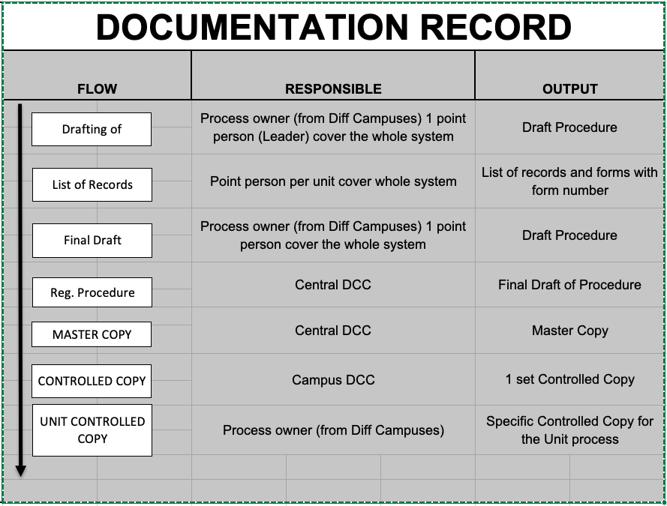
 | Context of the Organization | Coaching/review of the following records for the identification of context of the organization:  - SWOT Analysis Form  - Needs and Expectation of Interested Party  - Risk Assessment Registry  - Opportunities Action Plan
The following flow should be followed in accomplishing the identification of context and risk assessment process:
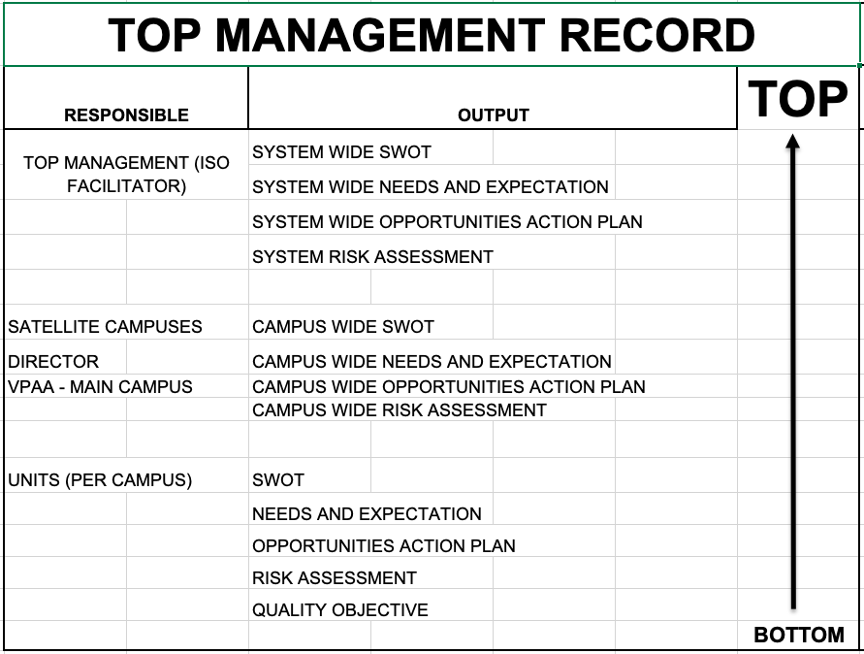
 | Quality Objectives | Coaching of the Quality objectives for each unit per campus.
 | Diagram in Identification of Risk and Opportunities | 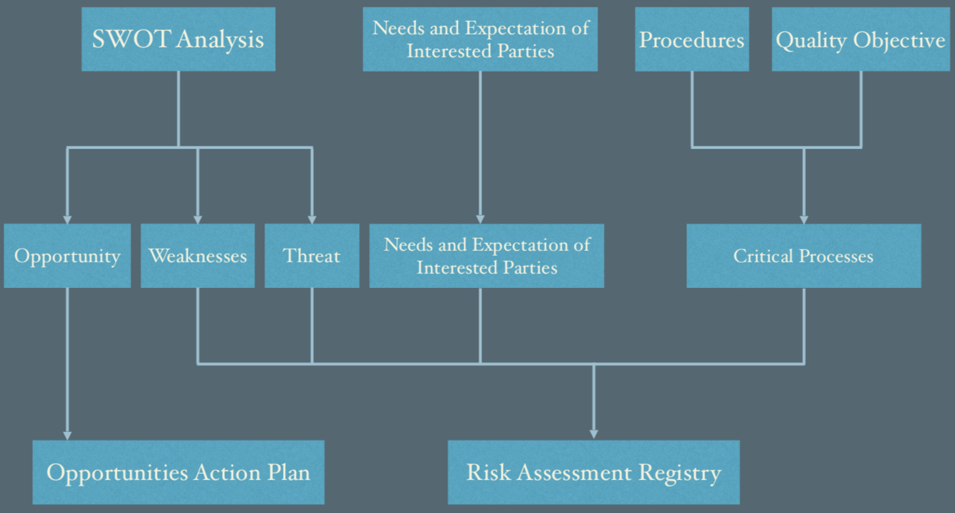  Potential failure to comply with
DCC |  | The following dates should be followed for the registration of procedure (Considering Plan A):  - Date Received (Upper part of DRRRF): April 29, 2019  - Registration Date/Master Copy Stamp Date: June 22, 2019  - Distribution Date/Controlled Copy Stamp Date: June 29, 2019  - Execution date/Implementation Date: June 3, 2019
 | Registration Process | Coaching of the following records for the registration:  - List of Records  - Master Record Control Register  - Document Review Request and Registration Form  - Document distribution retrieval and disposal  - DCC Stamps – required on next visit to procure a stamp
 | Document Distribution, Retrieval and Disposal Form | The following instructions has been advised during the visit:  - The Central DCC shall produce 2 sets of CONTROLLED procedure to be distributed on a campus  - 1 set of procedure – all procedures  - 1 set of procedure – copy of unit available for the campus  - Central DCC shall require the Campus DCC to sign the “Document Distribution, Retrieval and Disposal Form” to reflect received CONTROLLED procedure.  - Campus DCC shall distribute the controlled of the Delivery Unit and require the Delivery Unit to sign the “Document Distribution, Retrieval and Disposal Form”
Budget | Budget Preparation Procedure | The following concerns should be rectified:  - Process for each campus was not yet available during the checking – it is advised that a monitoring sheet should be implemented for each campus for the monitoring of transport of reports from satellite campus to main campus.  - Flow Charting was not yet organized during the checking
 | Budget Execution Procedure | The following concerns should be rectified:  - Process for each campus was not yet available during the checking – it is advised that a monitoring sheet should be implemented for each campus for the monitoring of transport of reports from satellite campus to main campus.  - Flow Charting was not yet organized during the checking
 | Financial Accountability Procedure | The following concerns should be rectified:  - Process for each campus was not yet available during the checking – it is advised that a monitoring sheet should be implemented for each campus for the monitoring of transport of reports from satellite campus to main campus.  - Flow Charting was not yet organized during the checking
 | Quality Objective | Endorsed a Quality Objective:  “To achieve 100% accurate encoding of the proposed budget proposals from the University for the CY 2019”
Academic Affairs (Instruction Delivery) | Procedure | A flowchart has been endorsed during the visit to be use as a guide in drafting the procedure.
 | Assessment of Student Procedure | The following should be rectified:  - The procedure did not describe the accomplishment of item analysis after the assessment process  - The result of item analysis shall be used for the improvement of delivery of lessons for the next sem or during remediation.
 | Retention of Student Control Procedure | The procedure should describe process for the assessment of student who will take the removal exam.
 | Assessment of Student Promotion and Graduation Procedure | The following processes should be rectified:  - The procedure did not include the process of update of “rsuwebsams”  - A process of verification of grades should be done before grades go live online.
Planning | Strategic Planning Process | The following concerns should be rectified:  - No form for the consolidated Strat Plan
 | Monitoring and Evaluation | No drafted procedure during the visit for the monitoring and evaluation
Accounting | Quality Objective | Endorsed the following quality objective:  - “To achieve 100% on-time submission of financial report for CY 2019”  - “To achieve 0 disallowances for the utilization of funds for the CY 2019”
 | Procedure | For finalization of the following procedure:  - Disbursement Control Procedure  - Bank Reconciliation Control Procedure  - Preparation of Financial Statements Control Procedure
STA FE CAMPUS | Needs and Expectations | Already finalized the Needs and Expectation subject for transfer to the registered template
 | SWOT Analysis | Checked the presented SWOT subject for signature
 | Risk Assessment | Checked the presented Risk Assessment ready for signature upon issuance of form number
 | Opportunities Action Plan | Checked the Opportunities Action Plan ready for signature upon issuance of form number
Registrar | Handling of Students Record | Shall complete the responsibility and authority
 | SWOT Analysis | Shall finalize the SWOT Analysis
 | Risk Assessment | Shall finalize the risk assessment based on SWOT Analysis and interested party
 | Needs and Expectation | Shall provide the required expectation of identified interested parties
 | Opportunities Action Plan | Checked the Opportunities Action Plan ready to transfer to registered template and endorsed for signature
 | List of Records | Shall provide the required form number on the listed forms
 | Quality Objectives | Proposed quality objective statement:  1. To provide 100% on-time releasing of requested students/alumni records for CY 2019
Cashiering | Cashiering Control Procedure | Tagging of students during enrollment, collection of payments, disbursement of salaries/wages and allowances, preparation and issuance of checks, payment of petty cash. Already finalized the procedure
 | SWOT Analysis | Checked the presented SWOT Analysis and shall finalize to the registered template
 | Needs and Expectation | Checked the presented Needs and Expectations ready for transfer to the prescribed template
 | Risk Assessment | Shall finalize the risk assessment based on identified weaknesses and threats in SWOT Analysis and interested party in Needs and Expectations
 | Opportunities Action Plan | Checked the accomplished Opportunities Action Plan and already based on identified opportunities in SWOT Analysis
 | Quality Objectives | Proposed quality objective statement:  1. To achieve 100% accurate daily collections and deposits transaction for CY 2019
Library | Library Control Procedure | Shall include the references used in the procedure
CAJIDIOCAN CAMPUS | Needs and Expectations | Shall finalize the Needs and Expectation based on identified interested parties
 | SWOT Analysis | Shall finalize the SWOT Analysis based on KRA
 | Risk Assessment | Shall prepare the risk assessment based on identified weaknesses and threats in SWOT Analysis and interested party
 | Opportunities Action Plan | Shall prepare Opportunities Action Plan based on identified opportunities in SWOT Analysis
 | Medical Control Procedure | Checked the presented procedure and shall finalize as per discussion on the listed process
 | Dental control Procedure | Checked the presented procedure and shall finalize as per discussion on the listed process
SAN ANDRES CAMPUS | SWOT Analysis | Checked the presented SWOT Analysis and shall transfer to the prescribed business driver
 | Risk Assessment | Shall finalize the risk assessment based on identified issues in SWOT Analysis and interested parties
 | Needs and Expectation | Checked the presented Needs and Expectation and shall consolidate for the campus
Institute of Criminal, Justice Education | SWOT ANALYSIS | Checked the presented SWOT Analysis and already aligned with the prescribed business driver
 | Risk Assessment | Shall include the interested parties in addressing its risk
 | Quality Objectives | Proposed quality objective statement:  1. To achieve the passing rate of 65% for licensure examination for school year 2019-2020.
Extension | SWOT Analysis | Checked the presented SWOT Analysis and aligned with the prescribed business driver
 | Risk Assessment | Shall finalize Risk Assessment based on identified weaknesses and threats and interested party
 | Needs and Expectations | Shall finalize the needs and expectation based on identified interested party
 | Opportunities Action Plan | Coached the preparation of Opportunities Action Plan
 | Extension Management Control Procedure | Checked the presented procedure subject for finalization and start with the word “shall” in the description of the procedure
 | Quality Objectives | Proposed quality objective statement:  1. To achieve the required 3,700 persons trained weighted by the length of training for CY 2019
IGS | Master’s Thesis and Dissertation Control Procedure | Checked the presented procedure ready for finalization and document review
 | Quality Objectives | Proposed quality objective statement:  1. To increase by 5% the number of enrollees for School Year 2019-2020
SUPPLY OFFICE | Supply Management Control Procedure | Checked the presented procedure ready for document review
 | Procurement Control Procedure | Checked the presented procedure subject for finalization
 | Evaluation of External Provider Procedure | Checked the presented procedure subject for finalization
 | Calibration Control procedure | Not yet finalized
 | SWOT Analysis | Shall specify the process being addressed with regards to internal and external issues
 | Needs and Expectations | Shall include the COA in the list
 | Risk Assessment | Shall finalized the risk assessment
 | Opportunities Action Plan | Shall prepare the Opportunities Action Plan based on SWOT Analysis
 | Quality Objectives | Proposed quality objective statement:  1. To serve at least 90% of received Purchase Request from the end user for CY 2019
HR | Human Resources Management Procedure | Checked the presented procedure:  Shall provide the reference documents used in the preparation of the procedure
 | Handling of Grievance Procedure | Checked the presented procedure
 | Strategic Performance Management Procedure | Shall provide the responsibility and authority
 | Rewards and Recognition Procedure | Checked the presented procedure
 | Payroll and Remittance Control Procedure | Checked the presented procedure and shall complete the details of the procedure as per clauses.
 | SWOT Analysis | Not yet finalized
 | Quality Objectives | Proposed quality objective statement:  1. To achieve 100% delivery of syllabi per semester for school year 2019-2020.  2. To provide all employees with at least one (1) training for CY 2019.
BAC | BAC Control Procedure | Checked the presented procedure subject for finalization
 | SWOT Analysis | SWOT Analysis not yet finalized
ROMBLON CAMPUS | SWOT Analysis | Checked the presented SWOT Analysis subject for finalization
 | Needs and Expectation | Shall finalize the needs and expectation of interested parties
 | Risk Assessment | Shall finalize the identified weaknesses and threats and needs and expectation
COLLEGE OF ARTS AND SCIENCES | Opportunities Action Plan | Shall provide specific action plan meet the opportunities
CALATRAVA CAMPUS | SWOT Analysis | Shall finalize the SWOT Analysis
Academic Affairs | Quality Objectives | Proposed quality objective statement:  1. To achieve 100% delivery of syllabi per semester for school year 2019-2020.
Institute of Information Technology | SWOT Analysis | Shall finalize the presented SWOT Analysis based on identified business driver
 | Risk Assessment | Shall prepare the risk assessment of identified weaknesses and threats in SWOT Analysis and identified interested party
 | Needs and Expectation | Shall prepare the needs and expectations of identified interested parties
 | Opportunities Action Plan | Shall prepare the Opportunities Action Plan based on identified opportunities in SWOT Analysis
 | Quality Objectives | Proposed quality objective statement:  1. To achieve 100% delivery of syllabi per semester for school year 2019-2020.
HR | Quality Objectives | Proposed quality objective statement:  1. To achieve 100% delivery of syllabi per semester for school year 2019-2020.

Part 2: Reminders / Assignments
Concerned Department / Section | Reminder / Assignment
All Departments/ Units | Start the review process of drafted procedures
 | Prepare a List of Records (Identify Maintenance and Preservation Period)
The organization should start conducting Risk Management by using the following forms:
- Risk Assessment Registry
- Opportunities Action Plan
- SWOT
- Needs and Expectations of Interested Parties

Part 3 (If necessary):
Client’s Concerns/Questions | Consultants’ Advice | Remarks
Attachment: Documentation & Forms Monitoring

Other Concerns:

Suggested agenda for next visit

Rev No. | Revision Date | Revision History | Conducted / Updated by
Ø | March 7~8, 2019 | Initial Documentation Coaching/Gap Analysis | Eric Vinluan/Enrico Pendon
1 | March 25-28, 2019 | Checking of procedure, List of Records, SWOT, Needs, Opportunities Action Plan, risk assessment and quality objectives | Christian john Vinluan/Enrico Pendon

Client Confirmation:

_______________________
Signature over printed name

